Selected Gate Way Devices Options

1)Advantech-ESRP-CSS-UNO1372

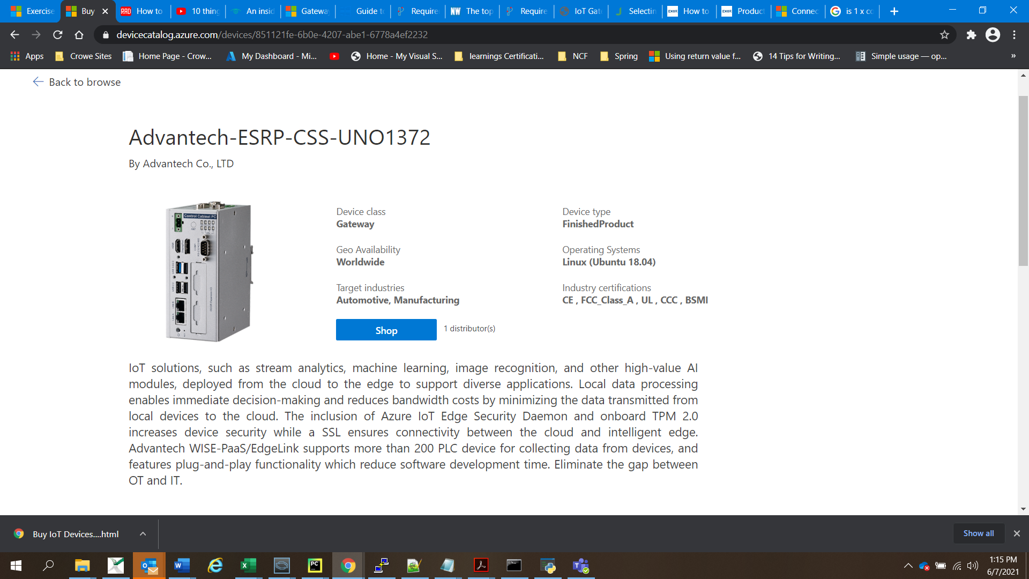

Ram: 4 Gb,. Ram:32Gb, Os: Linux, Processor Name: Intel® Celeron® J1900 (2 GHz)

2) Advantech-ESRP-CSS-UNO2271 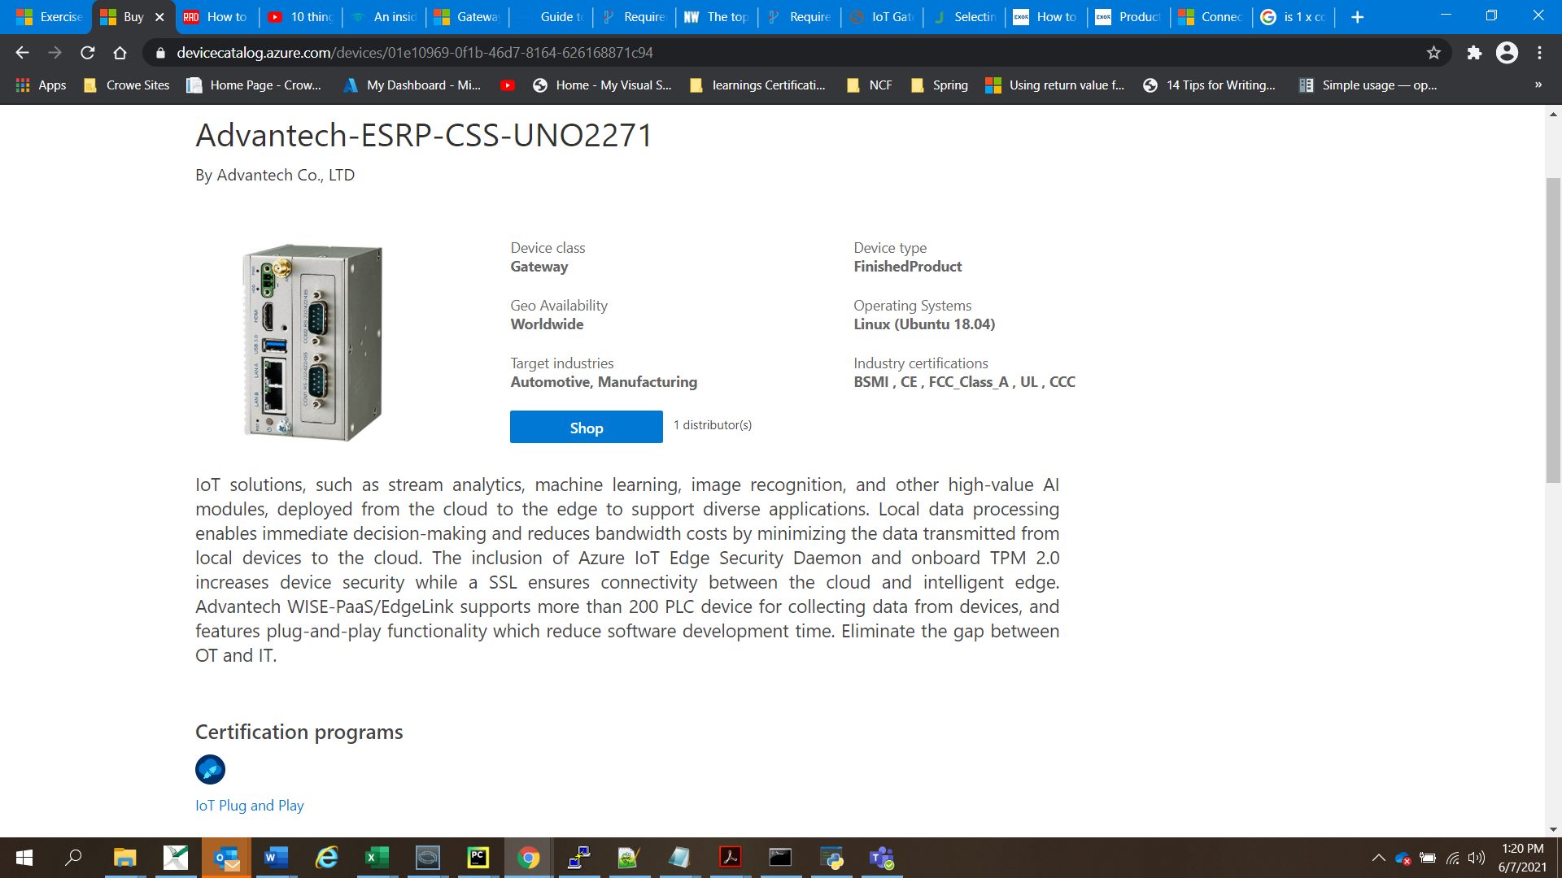

Ram: 4 Gb,. Ram:32Gb, Os: Linux, Processor Name: Intel® Atom™ E3825 (1.33 GHz)

Price : Around $857

3) Advantech-ESRP-CSS-UNO2372

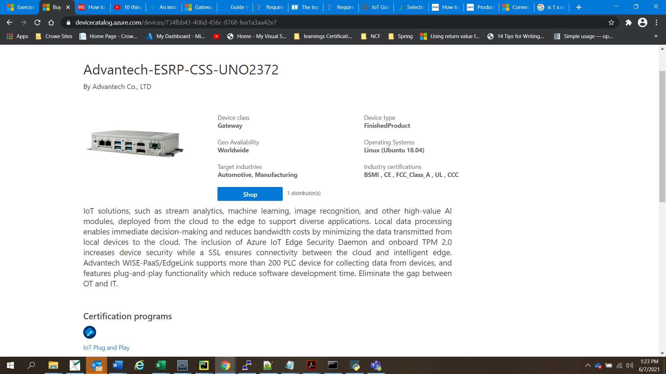

Ram: 4 Gb,. Ram:64Gb, Os: Linux, Processor Name: Intel® Celeron™ J1900 (2.0 GHz)

4) CloudPlug edge+

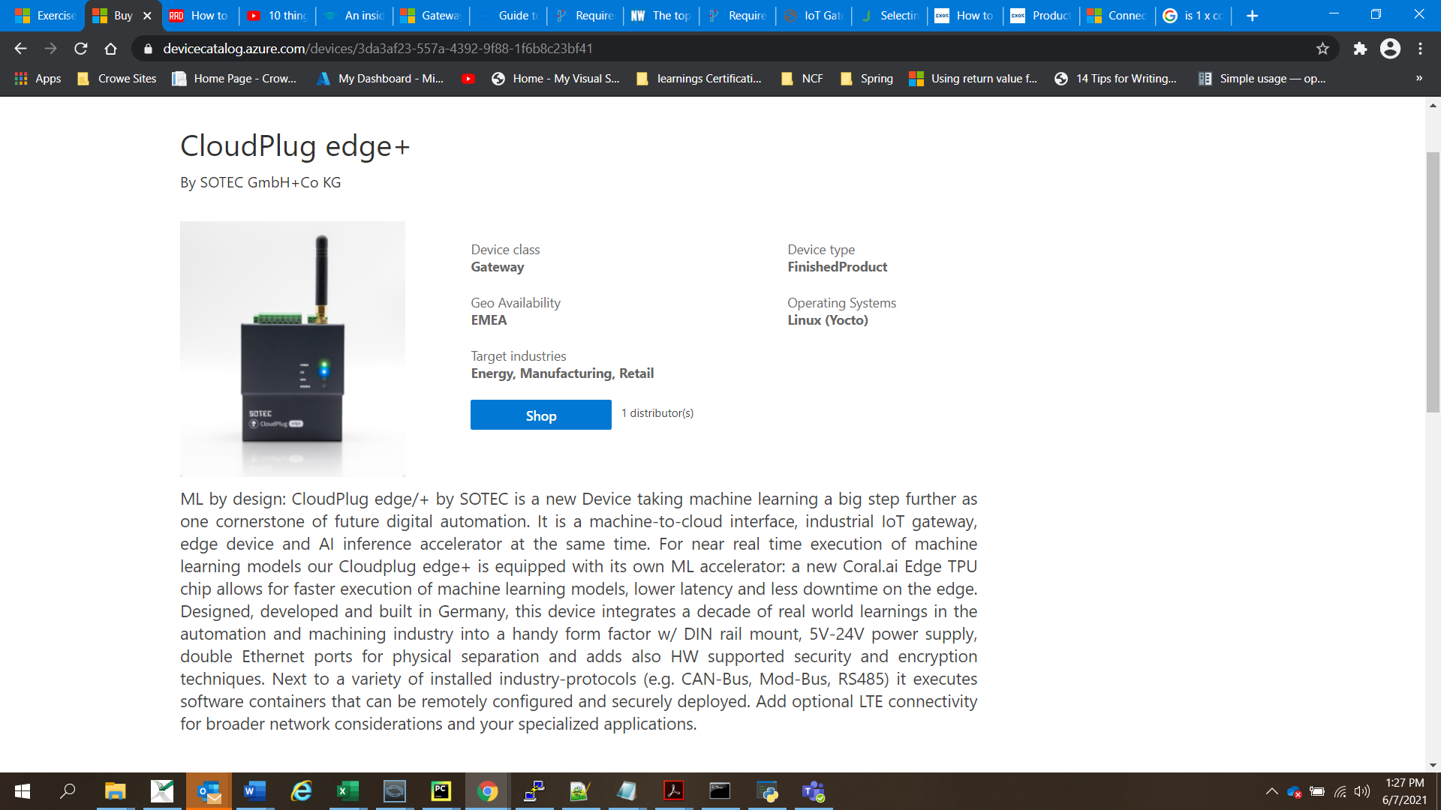

Ram: 4 Gb,. Ram:8Gb, Os: Linux, Processor Name: iMX8

5) OpenBlocks IoT VX2

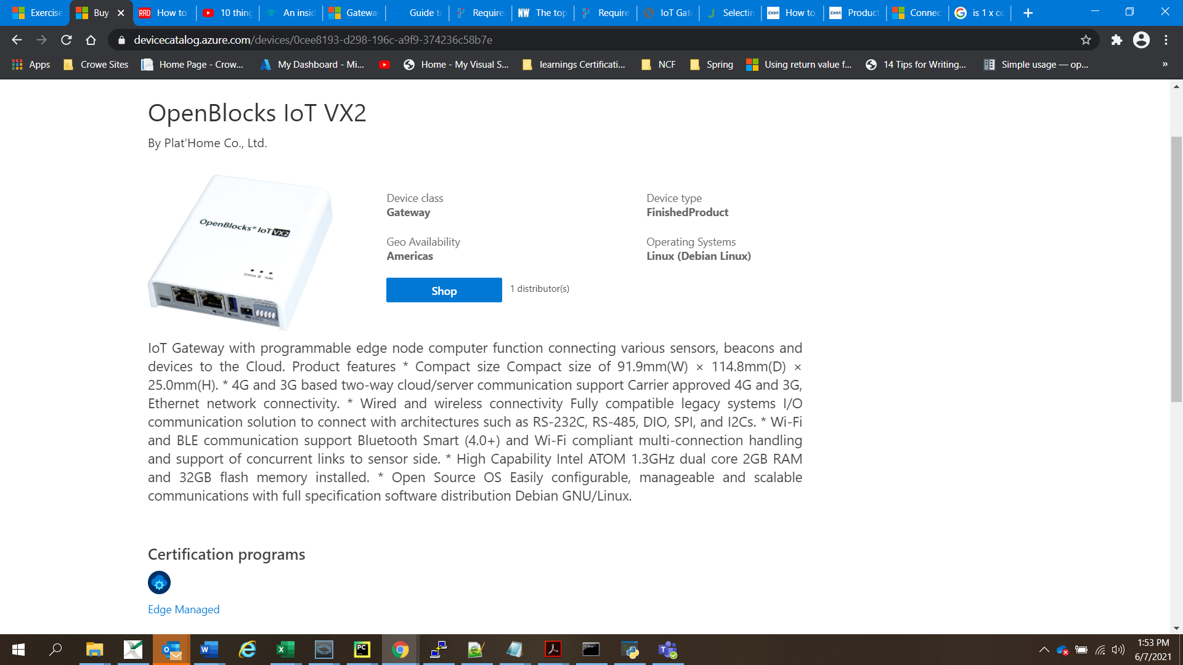

6) Advantech-EIS-D210

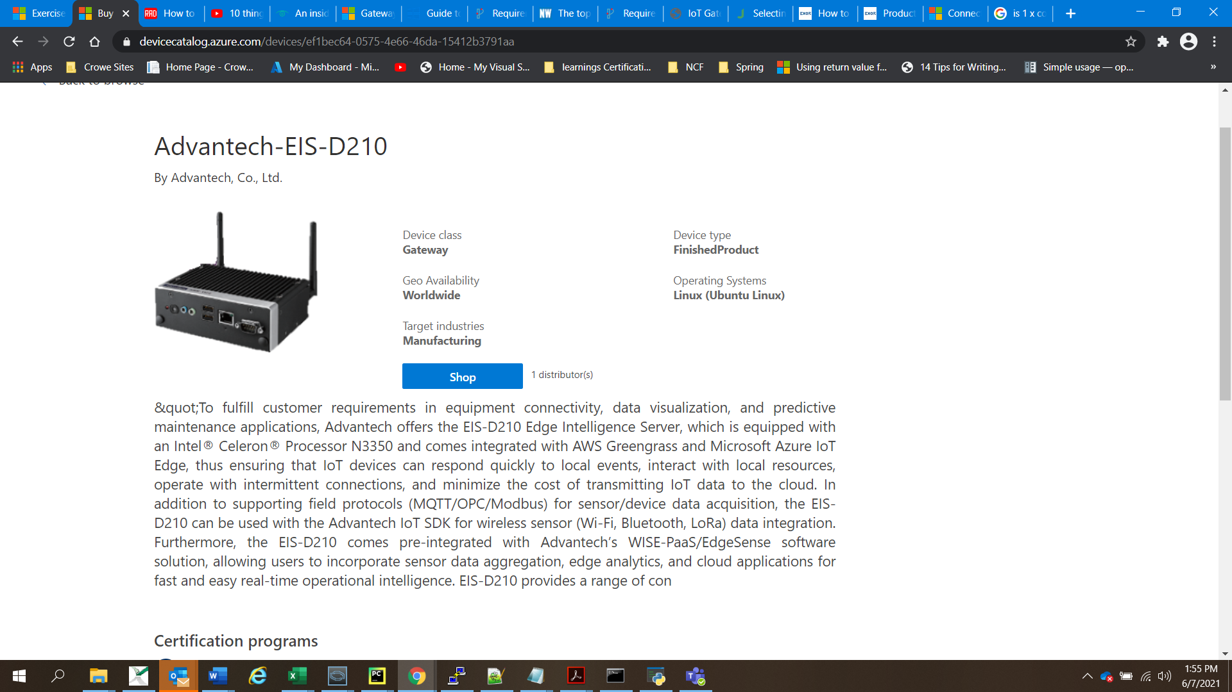

7)xGATEWAY PURE

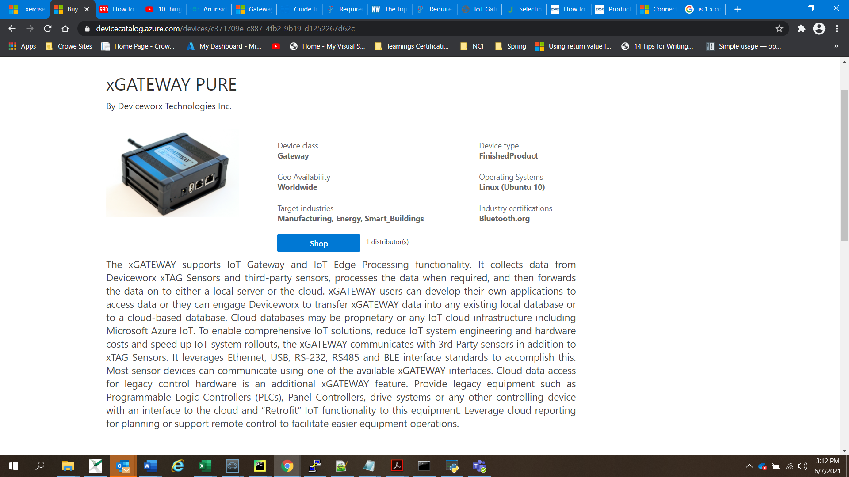

Ram: 2 Gb,. Ram:16 Gb, Os: Linux, Processor Name: i.MX 8M Mini Price : $810-990

8) ASUS-PE100A

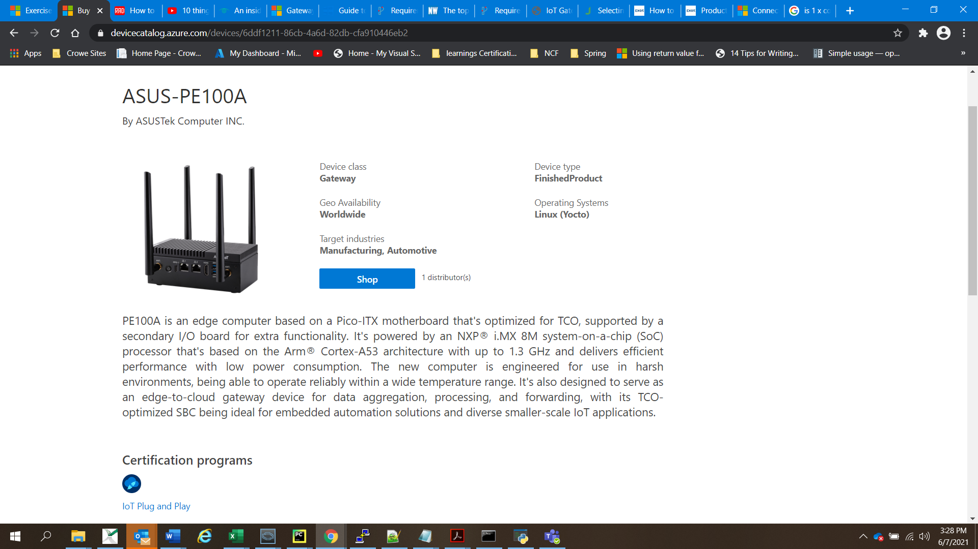

Ram: 4 Gb,. Ram:16 Gb, Os: Linux, Processor Name: NXP® i.MX 8M ARM Cortex-A53 core 1.3 GHz

Price: $290-$550

9) IBR210

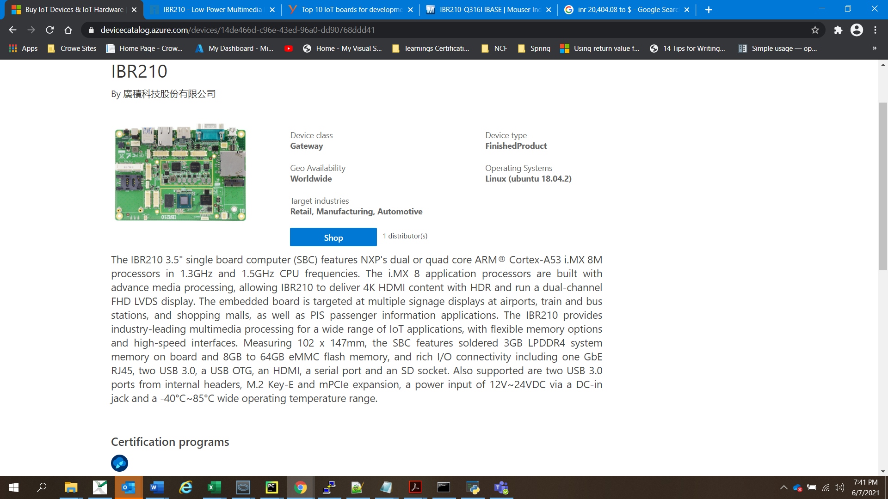

Ram: 3 Gb,. Ram:16 Gb, Os: Linux, Processor Name: i.mx8m Price:$280

